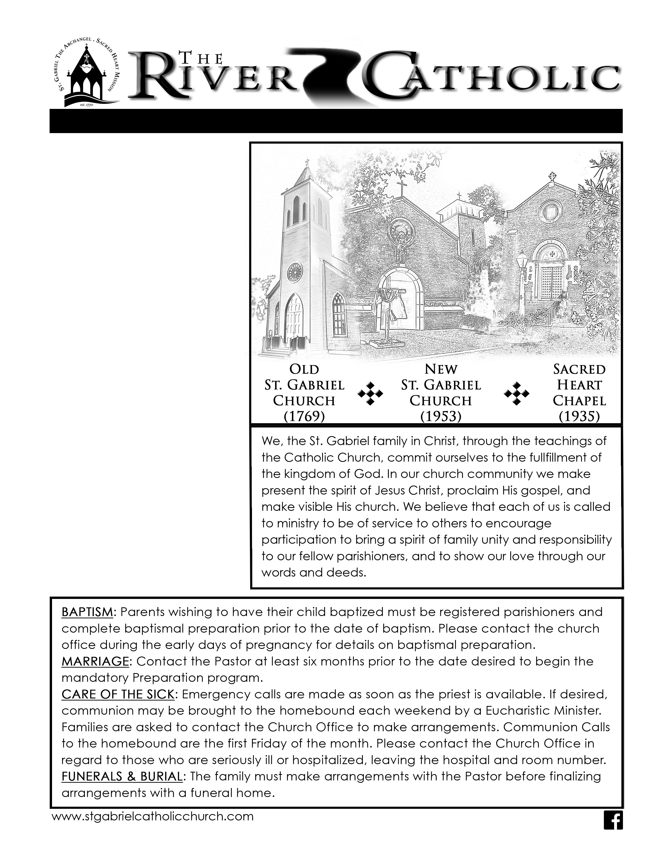
TWENTY FOURTH SUNDAY OF ORDINARY TIME 9/12/21 VOL. 40 NO. 01
3625 HIGHWAY 75
ST. GABRIEL, LOUISIANA 70776
Phone: 225-642-8441
Fax: 225-642-8491
stgabrielcatholi@bellsouth.net

OFFICE HOURS:
Monday-Thursday, 8am–3pm
(closed 12– 1pm for lunch)
Friday, 8am–12pm

PASTOR:
Reverend Charles R. Landry

ADMINISTRATIVE
ASSISTANTS
Myra G. Tircuit
Barbara V. Hornstein

CONFESSION
First Saturday, 3:15pm.&
by appointment
VIGIL MASS
Saturday, 4pm.
SUNDAY MASS
Sunday, 8am & 10am
Presently no mass @ Carville
DAILY MASS
Tuesday, Wednesday, Thursday, Friday, 8am
HOLY DAY MASSES
8am & 7pm
STEWARDSHIP OF FINANCE
WEEKLY ATTENDANCE 257
WEEKLY BUDGET $7,975.66
AMOUNT COLLECTED

NUMBER OF DONATIONS 109
There will be 2 envelopes 9/18-19, reg. & Religious Educ..
Your weekly donations help meet our immediate needs, repairs and improvements. We thank all who give of their time, talent and treasure to our parish community. We always appreciate your generosity.
Eighteenth Sunday in Ordinary Time 08/02/2020 VOL. 37, NO. 37
Today’s reading is the turning point in Mark’s Gospel. In the presentation of the life and ministry of Jesus found in the Gospel of Mark, the deeds of Jesus have shown Jesus to be the Son of God. Yet many, including Jesus’ disciples, have not yet realized his identity. In today’s Gospel, Jesus asks the disciples for a field report by asking what others say about him. He then turns the question directly to the disciples and asks what they believe. Peter speaks for all of them when he announces that they believe Jesus to be the Christ.
The word Christ is the Greek translation of the Hebrew word for Messiah, which means “the anointed one.” At the time of Jesus, the image of the Messiah was laden with popular expectations, most of which looked for a political leader who would free the Jewish people from Roman occupation. Jesus does not appear to have used this term for himself. As we see in today’s reading, Jesus refers to himself instead as the Son of Man, a term derived from the Jewish Scriptures, found in the Book of Daniel and in other apocryphal writings. Many scholars suggest that the phrase Son of Man is best understood to mean “human being.”
Now that the disciples have acknowledged Jesus as the Christ, Jesus confides in them the outcome of his ministry: he will be rejected, must suffer and die, and will rise after three days. Peter rejects this prediction, and Jesus rebukes him severely. The image of Christ that Jesus is giving is not the image of the Messiah that Peter was expecting. Jesus then teaches the crowd and the disciples about the path of discipleship: To be Chris’s disciple is to follow in the way of the cross.
We can easily miss the fear that Jesus’ words must have evoked in his disciples. Death by crucifixion was all too familiar as a method of execution in Roman-occupied territories. It was also an omnipresent danger to the Christian community for whom Mark wrote. The path that Jesus was inviting his disciples to share meant tremendous suffering and death. This is the kind of radical commitment and sacrifice that Jesus calls us to adopt for the sake of the Gospel.

Together We Can!

If you would like to receive the Sacrament of Reconciliation, please contact Fr. Charlie for an appointment.

Sadly, the bus trip must be cancelled. The exhibit is uncertain of dates, so we figured it is better to cancel and perhaps in 2022 it may happen.
Please call Jeanne or Brenda concerning money.
Jeanne Billodeaux, Brenda Blanchard,
362-1618, 677-9464,
jbilodo@cox.net brendatblanchard@gmail.com
Until we receive other notice, all masses and Eucharistic adoration will be held in church. Remember to keep your social distance. Be sure to wear your mask!
The opening of Rel Ed Program for this 2021-2022 season is delayed 1 week, until 9/20. If there is a problem call Myra.
We offer our prayers and sympathy to our faith community who died in Christ, Eugenie (Genie) LaPlace.
From the Diocese –
Due to the on-going threat of Covid, the Diocese has elected not to host the annual Anniversary Mass for married couples. At the same time, Bishop Duca would still like to acknowledge the commitment and dedication of these anniversary couples who are models of selfless love for our Church. Therefore, the Bishop has asked us to identify those marrieds celebrating their 25, 50 and over 65 years of marriage during 2021.
So, there is a form to be completed. Please stop by the office to complete this or take one home and drop off at the office to Barbara. You also can scan or email tomgernon@diobr.org. The deadline for forms returning those forms to the Diocese is Wednesday, Oct.20. If you have any questions,
Please call Mila Gernon at 242-0323 at the Diocese.

24th SUNDAY ORDINARY TIME
Sun. 12 8:00 a.m. MASS
10:00 a.m. MASS

Mon. 13 8:00 a.m. No Mass
6:30 p.m. Catechist Workshop

Tues. 14 7:00 a.m. Men’s Reflection
8:00 a.m. Daily Mass
8:30 a.m. Adoration
6:00 p.m. KCs in PAC
6:00 p.m. Confirmation Team Mtg.

Wed. 15 8:00 a.m. Daily Mass BUS TRIP CANCELLED!!!!
6:30 p.m. Pastoral Council Mtg.

Thurs. 16 8:00 a.m. Daily Mass

Fri. 17 8:00 a.m. Daily Mass
7:00 p.m. Wedding in Church

Sat. 18 9:00 a.m. 1st Reconciliation Class
1:00 p.m. Convalidation of Marriage
4:00 p.m. Vigil Mass
25th SUNDAY ORDINARY TIME
Sun. 19 8:00 a.m. MASS
10:00 a.m. MASS
2:00 p.m. Confirmation Retreat

Mon. 20 8:00 a.m. No Mass
6:30 p.m. Rel Ed Gr 1-12

Tues. 21 7:00 a.m. Men’s Reflection
8:00 a.m. Daily Mass
8:30 a.m. Adoration

Wed. 22 8:00 a.m. Daily Mass

Thurs. 23 8:00 a.m. Daily Mass

Fri. 24 8:00 a.m. Daily Mass

Sat. 25 4:00 p.m. Vigil Mass
26th SUNDAY ORDINARY TIME
Sun. 26 8:00 a.m. MASS
10:00 a.m. MASS

Mon. 27 8:00 a.m. No Mass
6:30 p.m. Rel Ed Gr 1-12

Tues. 28 7:00 a.m. Men’s Reflection
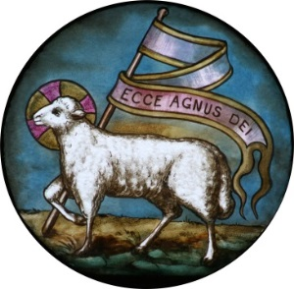
8:00 a.m. Daily Mass

DAILY READINGS
24th SUNDAY IN ORDINARY TIME
Isaiah 50:4c-9a; James 2:14-18; Mark 8:27-35
Monday, September 13 Daily Readings
1 Timothy 2:1-8; Luke 7:1-10
Tuesday, September 14 Daily Readings
Numbers 21:4b-9; Philippians 2:6-11; John 3:13-17
Wednesday, September 15 Daily Readings
1 Timothy 3:14-16; John 19:25-27
Thursday, September 16 Daily Readings
1 Timothy 4:12-16; Luke 7:36-50
Friday, September 17 Daily Reading
1 Timothy 6:2c-12;Luke 8:1-3
Saturday, September 18 Daily Readings
1 Timothy 6:13-16; Luke 8:4-15
25th SUNDAY IN ORDINARY TIME
Wisdom 2:12, 17-20; James 3:16-4:3; Mark 9:30-37

Pray for our Sick and Homebounds: Frank Banta, Sr., Betty Jean Barbay, Billy and Phyllis Babin, Joan Chapman, Melissa Conrad, Joyce Crochet, Lily Fairchild, Carolyn Harelson, Michael Landaiche, , Anthony & Bessie Pizzolato, and Flory Reynolds. Include in your prayers all of the sick & suffering in our families especially those living in nursing homes. Also, pray for peace in the world, & for all men and women in our armed forces.

IF YOU WOULD LIKE YOUR NAME REMOVED FROM THIS LIST, PLEASE CONTACT THE PARISH OFFICE.
WEEKLY MASS INTENTIONS
09/13 8:00 a.m. No Mass
09/14 8:00 a.m. Warthen Family; Eugene LeBlanc, Jr.
Comeaux-Barbay Families
09/15 8:00 a.m. Carl, Genie & Jared LaPlace; Joyce Gaudet Booth
Dr. Sidney Thibodeaux
09/16 8:00a.m. Beverly, Greg & A.G. Wright, Jr.
09/17 8:00 a.m. M/M L.g. Hoffmann, Sr. & Jr.
Allen White; White-Crochet Families
09/18 4:00 p.m. M/M Elllis Gaudet
Dewey Hymel Fly. & Betty
Frances & Lerry Peltier; Peltier-Panepinto Families
09/19 8:00 a.m. Alvin Fairchild, Sr.; Elouise Conant Martin
10:00 a.m For the Parish
09/20 8:00 a.m. No Mass

The Sanctuary Lamp will burn the week of September 12-18 in memory
of Elouse Conant Martin.

