Parish School of Religion
2021 – 2022

Information/Registration Packets

St. Gabriel Catholic Church
3625 Highway 75
St. Gabriel, Louisiana 70776
225-642-8441

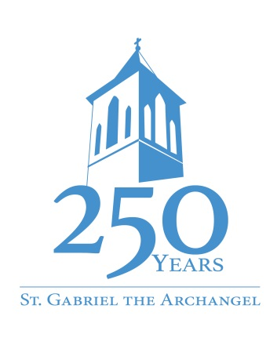
ST. GABRIEL CATHOLIC CHURCH
3625 Highway 75
St. Gabriel, LA 70776
225-642-8441; fax 225-642-8491
www.stgabrielcatholicchurch.com
stgabrielcatholi@bellsouth.net

July 9, 2021

Dear Parent(s),

We hope you and your family is remaining safe during the Covid-19 pandemic. Health and safety guidelines from local, state, and federal governments, as well as the Diocese of Baton Rouge have been implemented on our campus and through the various activities on our campus.

Our current plans for our 2021 – 2022 Parish School of Religion are for our sessions to resume on campus for those families who wish to do so. We have a plan for those families who do not wish to attend on campus but are interested in the program. We also work in conjunction with our neighboring parishes for our students who may wish to attend a program on campus but St. Gabriel’s time frame does not work for them.

Please find attached a registration form for students who wish to enroll in our program. Please fill out one form per registering student. Forms, along with a $35.00 fee per child is due in the parish office no later than Sunday, August 1, 2021.

Also attached is a copy of the calendar for the year. Please mark these dates on your family calendar. Our first gathering will be Opening Mass/Open House on Monday, August 30 at 6:30 P.M. in the Church.

If you have a child who may be interested in the Sacramental Preparation Programs of First Reconciliation, First Eucharist or Confirmation they should register for these program separately. Registration packets for these programs are available in the vestibule of the Church.

We are looking forward to working with your family on this journey of faith. If you have any questions, please feel free to contact us.

Sincerely,

Mrs. Myra G. Tircuit, D.R.E.
Parish School of Religion 2021 – 2022
CALENDAR OF SESSIONS
FIRST SEMESTER 2021

DATE CHAPTER/ACTIVITY

August 30 6:30 P.M. Opening Mass/Open House

September 13 Session #1
September 20 Session #2
September 27 Session #3
October 04 Session #4

October 11 NO SESSION

October 18 Session #5
October 25 Session #6
November 01 Session #7
November 08 Session #8

November 15 NO SESSION
November 22 NO SESSION THANKSGIVING WEEK

November 29 Session #9
December 06 Session #10
December 13 Session #11
December 20 Session #12 Large Group Gathering

December 27 NO SESSION – CHRISTMAS BREAK

SECOND SEMESTER 2022 -

DATE CHAPTER/ACTIVITY

January 03 NO SESSION – WINTER BREAK
January 10 Session #13 Circles of Grace as Required by Diocese
January 17 NO SESSION – Martin Luther King, Jr. Holiday

January 24 Session #14
January 31 Session #15
February 07 Session #16
February 14 Session #17

February 21 NO SESSION
February 28 NO SESSION – Mardi Gras

March 07 Session #18
March 14 Session #19
March 21 Session #20
March 28 Session #21

April 04 NO SESSION

April 11 Session #22
April 18 NO SESSION – EASTER BREAK
April 25 Session #23
May 02 Session #24 FINAL GATHERING

Choice you make for participating in program is by semesters. Students meeting on Campus will meet from 6:30 P.M. until 7:45 P.M. Students not meeting on Campus will complete work assigned weekly. They will meet with DRE twice during the semester. Appointments for these meetings should be scheduled by parents. Parents of students not on campus are required to stay at meetings with their child. Students not participating on campus will participate in large group activities. Teachers are not responsible for providing the extra/special things they do in class to the at-home students. If you are interested in faith formation and this program does not work for your family, please contact the parish office.

